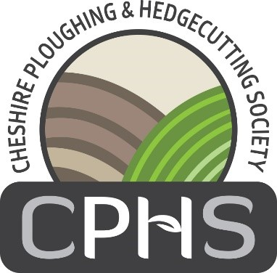

**CHESHIRE PLOUGHING & HEDGECUTTING SOCIETY**

Fields View, Elton Road, Ettiley Heath, Sandbach, CW11 3NE

Patron – The Marquess of Cholmondeley

President – Geoff & Graham Warburton

Chairman – Doug Richardson

Registered Charity No. 215528

Tel: 01270 765404 Mobile: 07703 126142

Email: [sueball_lynhouse@hotmail.co.uk](mailto:sueball_lynhouse@hotmail.co.uk)

[www.cheshireploughing.org.uk](http://www.cheshireploughing.org.uk)

June 2025

**2025 NORTH WEST AND CHESHIRE COUNTY CHAMPIONSHIP**

**HATLEY FARM, HATLEY LANE,**

**FRODSHAM, WA6 6XX**

**WEDNESDAY 24TH SEPTEMBER 2025**

**By kind permission of The Warburton Families**

Dear

We are very fortunate this year to be returning to Hatley Farm, Frodsham, we were last at this site 2015 and we are extremely grateful to our hosts for offering us the opportunity to come back to their farm. This year will be the 99th Cheshire Ploughing Match. We are hoping the weather is kind to us and that we can all enjoy a wonderful day.

I enclose an Application Form for the hedgelaying classes at the 2025 Match, the closing date is Friday 22nd August and late entries will be considered at the society’s discretion.

**Classes are** Class 12 Open

Class 13 Cheshire Competitors

Class 14 Novice (Anyone who has won **Two Novice** 1st Prizes must enter in the Open Class 12, or Cheshire Class 13 if resident in Cheshire)

£10 will be paid to all competitors completing their length to the Judges satisfaction.

Prizes are 1st £45; 2nd £35; 3rd £25; 4th £15.

**Please note anyone acting in manner that is, in the opinion of the Stewards, dangerous will be disqualified**

Upon receipt of entry form you will be issued with the appropriate tickets and information of how to get to the match, these will be posted out in September.

If you require any other information do not hesitate to contact me

**CLOSING DATE FRIDAY 22nd AUGUST 2025**

Yours Sincerely

Sue

Susan Ball, Secretary

**CHESHIRE PLOUGHING AND HEDGECUTTING SOCIETY**

Registered Charity No: 215528

# 2025 NORTH WEST CHESHIRE COUNTY CHAMPIONSHIP

# 

# HATLEY FARM, HATLEY LANE,

# FRODSHAM, WA6 6XX

By kind permission of The Warburton Families

# WEDNESDAY 24TH SEPTEMBER 2025

**HEDGE LAYING ENTRY FORM**

|  |  |
| --- | --- |
| NAME |  |
| ADDRESS |  |
|  |  |
|  |  |
| POST CODE |  |
| TELEPHONE |  |
| MOBILE |  |
| EMAIL |  |
| DATE OF BIRTH (under 30) |  |
| CLASS NUMBER |  |

**USE OF CHAINSAWS**

The Cheshire Ploughing & Hedge cutting Society are permitting the use of chainsaws in their annual competition. Users must produce their valid certificate number and wear appropriate safety clothing at all times. The stewards will stop the use of the chainsaw if a competitor is seen to be not carrying out safe practise.

Signed…………………………………………………..

**PLEASE COMPLETE AND RETURN TO THE SECRETARY**

Susan Ball, Fields View, Elton Road, Ettiley Heath, Sandbach, CW11 3NE

Tel / Mob: 01270 765404 / 07703 126142

Email: sueball_lynhouse@hotmail.co.uk

**ENTRY FEE: £10** CHEQUES to be made payable to **CPHS**.

BACS Payments to Natwest Acct No 24424439 Sort Code 55 61 31

##### ENTRIES CLOSE : FRIDAY 22nd AUGUST 2025